Game Design Document

Team: Mazeland

# **Team**

| Name | Email | Games Played First Week | Spurpunk TD review |
| --- | --- | --- | --- |
| Shibo Zhang(Team Captain;Enemy Control) | shibozha@usc.edu | Kingdom Rush  2048  PUBG | https://youtu.be/Kke2brSLXVE |
| Mingdong Lyu(Product manager; Analytics) | mingdonl@usc.edu | The binding of Issac  Snake  2048  Slay the Spire | https://youtu.be/HX8jvAXe5ts |
| Zifeng Lin (Version Control) | zifengli@usc.edu | King of Glory  CrossFire  QQ Farm | https://www.youtube.com/watch?v=iwWn0_tOTyk |
| Xiujing Huang (User Interface) | xiujingh@usc.edu | Detroit become human  LOL  PUBG | https://www.youtube.com/watch?v=Hu2N8fc77CU |
| Tianding Zhang(programmer) | tianding@usc.edu | Kingdom Rush  Dota2  LOL | https://youtu.be/bNQvSRG7MDE |
| Yintang Yang (Programmer) | yintangy@usc.edu | Portal2  PUBG  Carrot Fantasy | https://youtu.be/exPrTCbu-ME |
| Yang Zhang（Game Feel, programmer ） | yangz673@usc.edu | Risk of Rain 2  Human Fall Flat  Portal2  Roach Race | https://youtu.be/X2eXk2_PhGY |
| Chuanshi Zhu(programmer) | zhuchuan@usc.edu | Weiro rpg  Among us  Richman 10 | https://youtu.be/_71f3Zo2sL0 |
| Ruize Zhang(Product manager,Analytics) | ruizezha@usc.edu | *Sid Meier's Civilization VI*  *Crusader Kings III* | https://www.youtube.com/watch?v=LEytUpuILrM |
| Minzhi Zhan(User Interface) | minzhizh@usc.edu | Animal crossing  The legend of zelda  Carrot fantasy | https://youtu.be/dsA9ySEOY-s |
| Jerzy Ramos Chen(Programmer) | ramosche@usc.edu | Don’t Starve, Genshin Impact, Stardew Valley | https://youtu.be/0amXbrHk1d8 |

# **Github and WebGL Link**

1. <https://github.com/Samberg-0808/Mazeland>
2. <https://mazeland.itch.io/divisible>

# **Game Overview**

Original Prototypes:

[Prototypes](https://docs.google.com/document/d/14tmkzz_W47w2EiTJmOj0cRHUVd3-8Sr9LyW5t0xK2cA/edit#)

## Genre

Survival, Collecting, Exploration, Math

## Goal

Survive until the last second and collect score to reach goal

## Mechanics

Player uses WASD to move in 2D plane

Player has 3 lives in total and each damage loses one life.

Player eliminates enemies if the number of the enemy is the factor of the number on the player

Player gets scores by collecting green circles or by killing enemies.

Player needs to avoid the black circle and cannot collide with the black circle.

Players can collect green circles with different scores to increase the player’s total score.

Collect enough Scores to reach the next level.

The black circle will shrink as time goes by.

## Math

Controlled random generation for point orbs, enemies, and assigned numbers

## 

## Game Description

Last-man-standing gameplay with the survival, exploration and scavenging elements of a survival game

### Detailed Idea:

Move the player orb to collect generated point cubes to increase total score. The player is able to eliminate certain cubes by collision. In the meanwhile, the battleground will gradually shrink to a random size. The play will have to stay in the battleground in order to be alive and reach certain points to level up.

### Drawing:

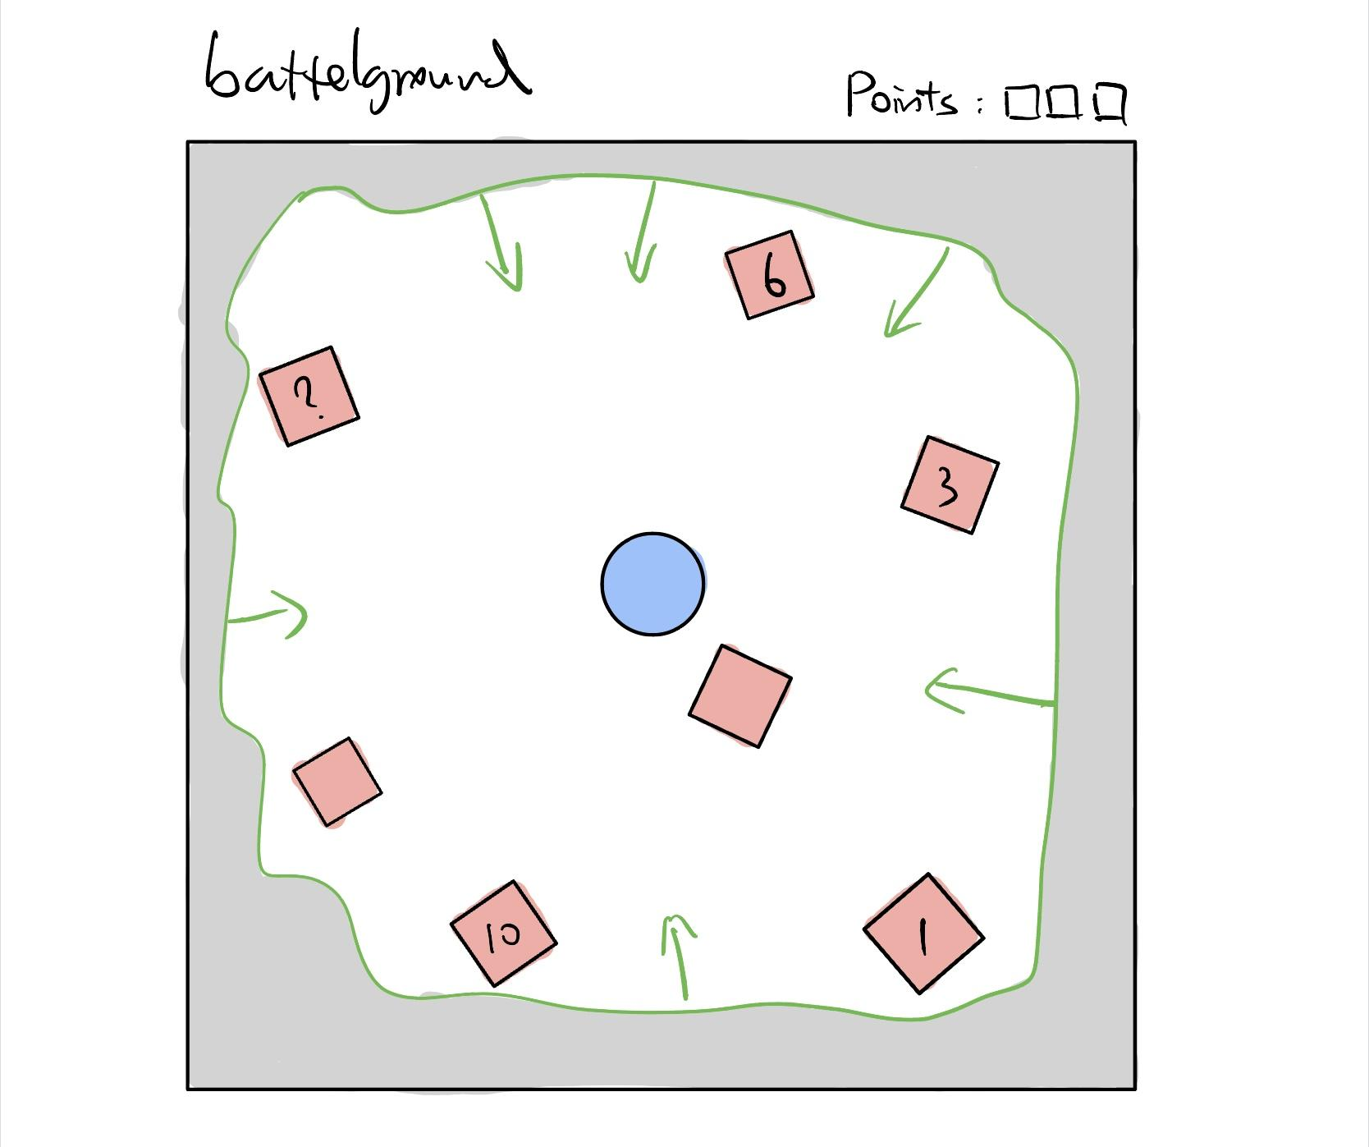

The player can move by using WASD. Collect points by colliding with cubes. Try to collect as many points as possible to level up. Always stay in the safe zone to avoid loss of points.

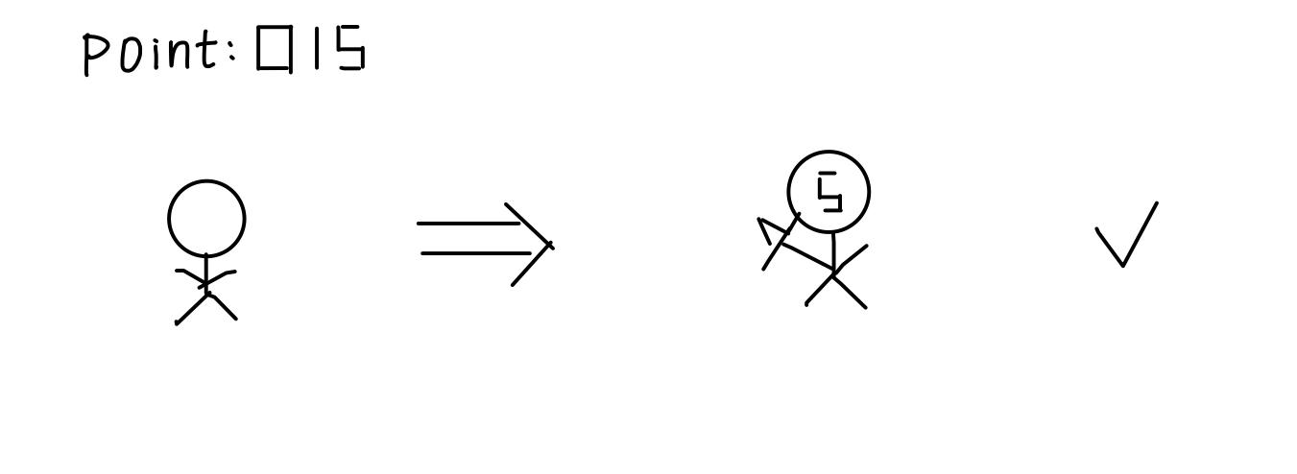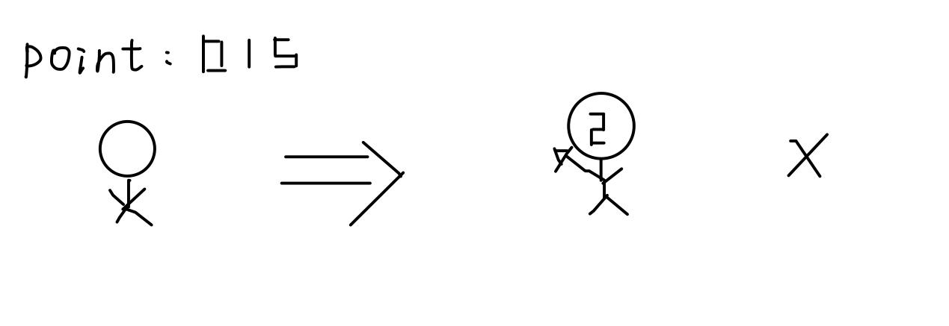

For example, if the player has point 15, the player can kill enemies with number 5 on it. However, the player cannot kill enemies with number 2 on it since 15 is not divisible by 2. If the player with points 15 hits enemies with number 2, the player will get penalties like decreasing two of the total points and generate an enemy with a number which is the reminder of it.

### Drawing for Level 1:

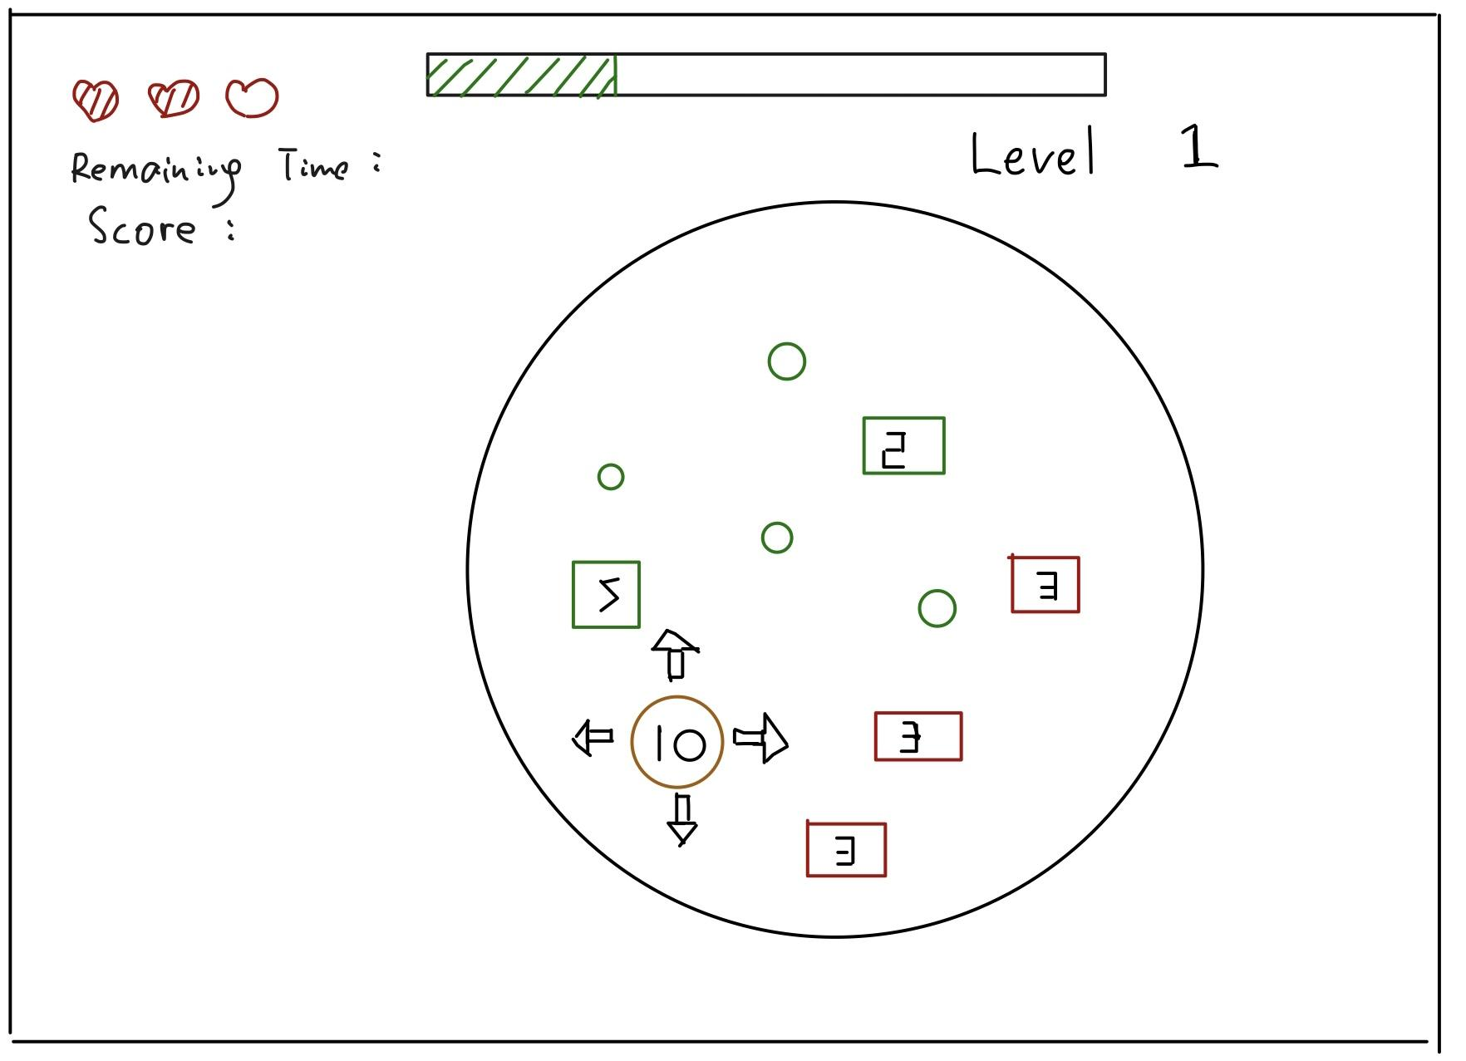

Level 1 is the basic idea of the game. It shows the basic game mechanics of the game and helps players get more familiar with our games. The goal for level1 is to collect enough points or kill enough enemies to reach a goal score.

### Drawing for Level 2:

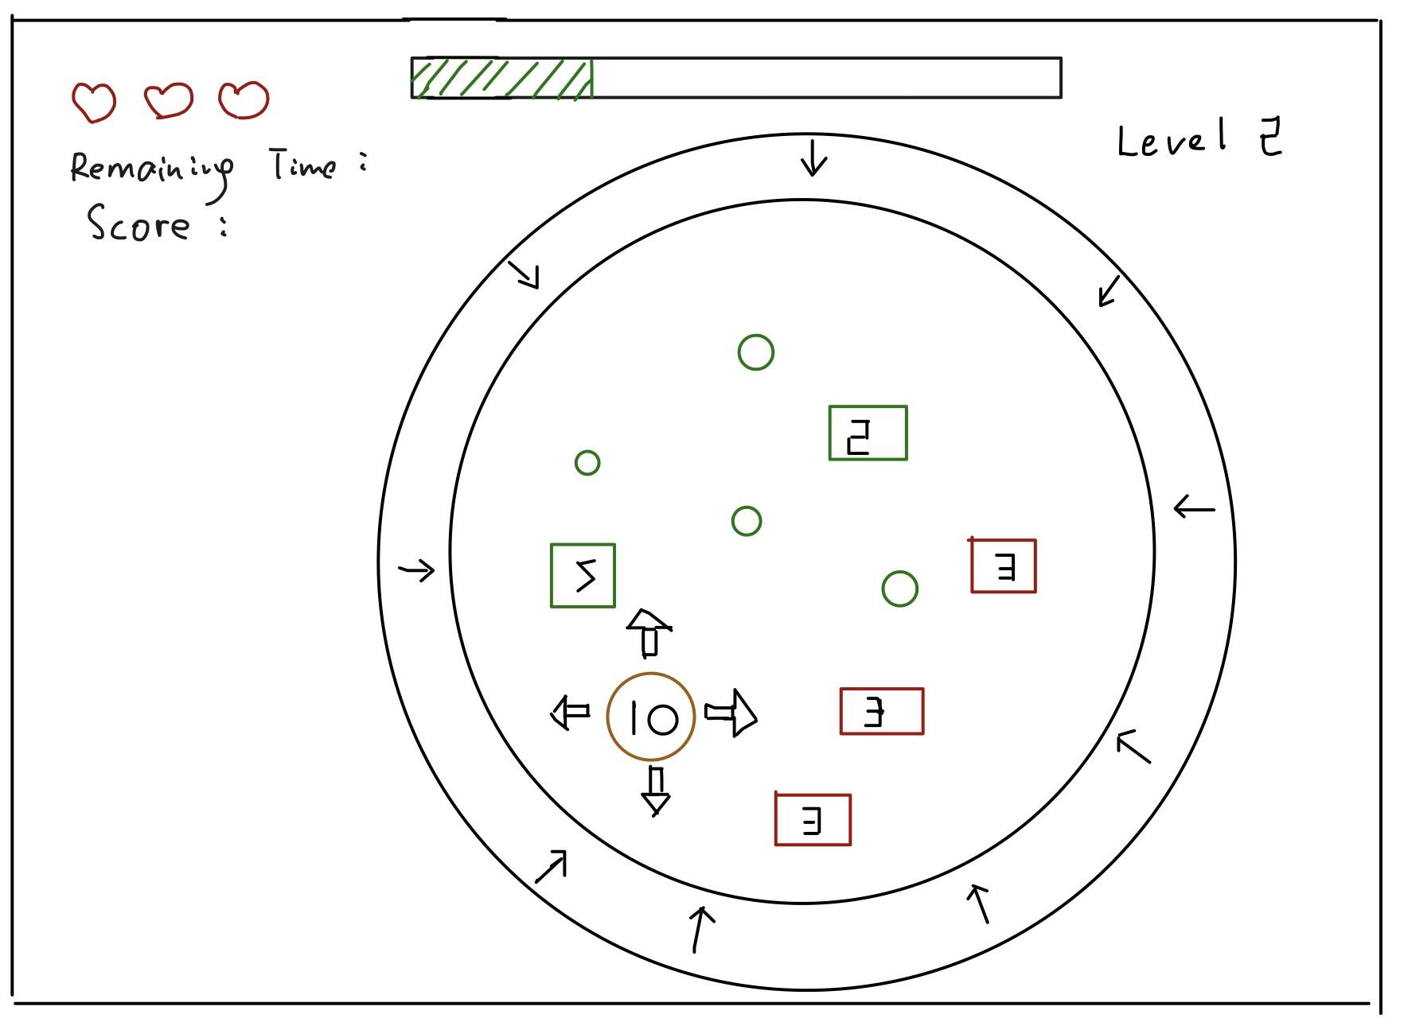

Except for the basic game mechanics, the outside circle starts to shrink and the player will get damage if the player hits the balck circle.The goal for level2 is to collect enough points or kill enough enemies to reach a goal score.

### Drawing for Level 3:

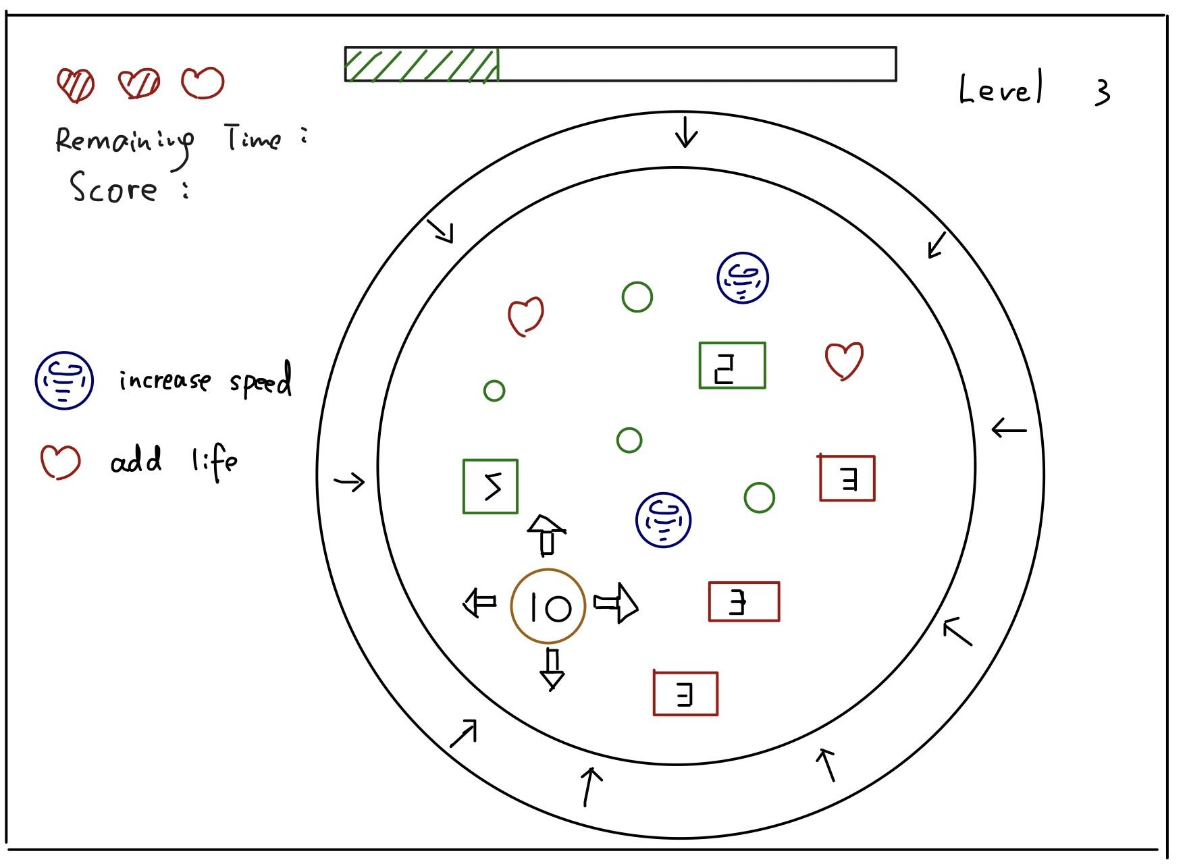

We add some items in level 3. The first item is “red heart”, players can get one more life if they collect it. The second item is “tornado”. It will increase the players’ movement speed. The goal for level3 is to collect enough points or kill enough enemies to reach a goal score.

### Drawing for Level 4:

### 

The level 4 has a stick rotating inside the circle. The circle will no longer shrink and players need to escape from the stick.The goal for level4 is to collect enough points or kill enough enemies to reach a goal score.

### Drawing for Level 5:

# 

Players still need to collect as many points as possible to complete this level, but their vision is blocked. They are only able to view a small area around themselves. The goal for level5 is to collect enough points or kill enough enemies to reach a goal score.

### Drawing for Level 6:

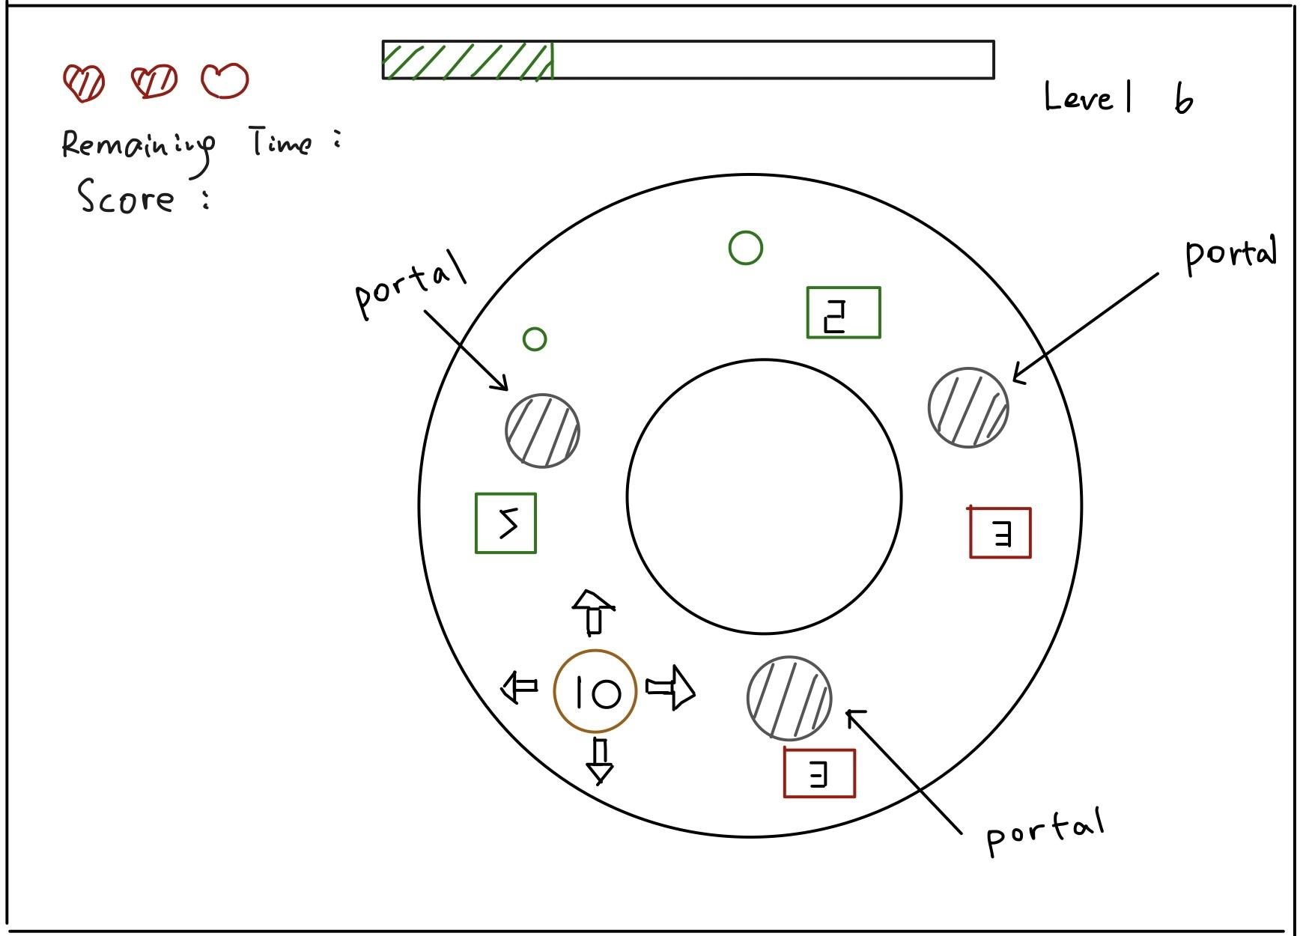

We add three portals at level 6. Players can travel to another portal if they control the yellow circle and collide with the portal. The goal for level6 is to collect enough points or kill enough enemies to reach a goal score.

# Analysis

Data collection:

* We send our metric to a Google Form through Unity. We can then get a spreadsheet with all the metrics tracked.

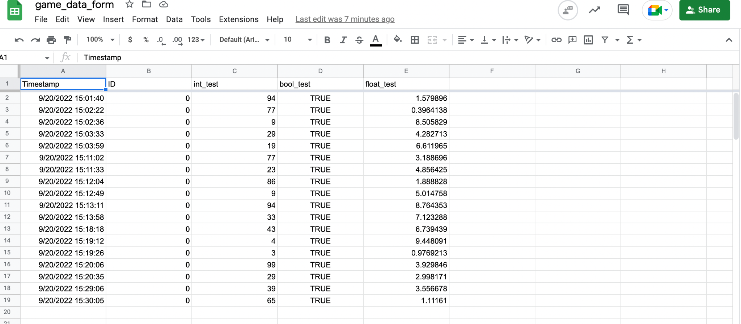

Data analysis:

We will save the data from the Google Form as the .csv file. The collected variables are starting time for each level, end time for each level, and the dead level for each player. We will then calculate the average survival time and number of players that pass/fail each level with pandas. The results of the data analysis will be plotted out by matplotlib.

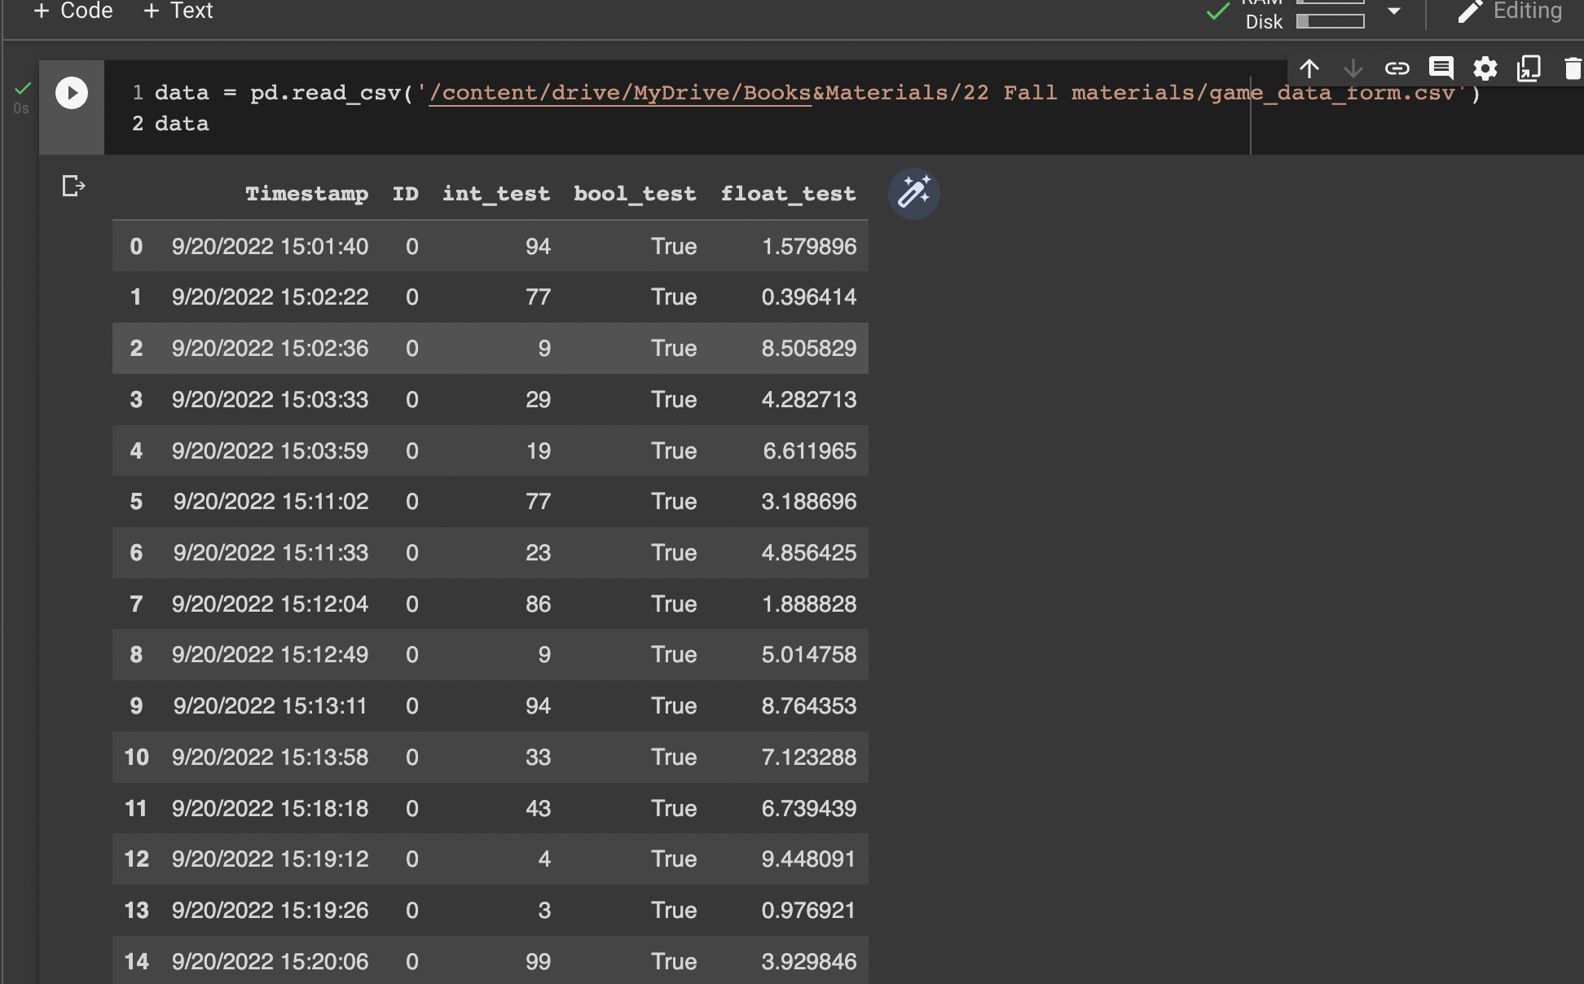

## Data 1 & 2:

***How long does the player need to get to the next level?***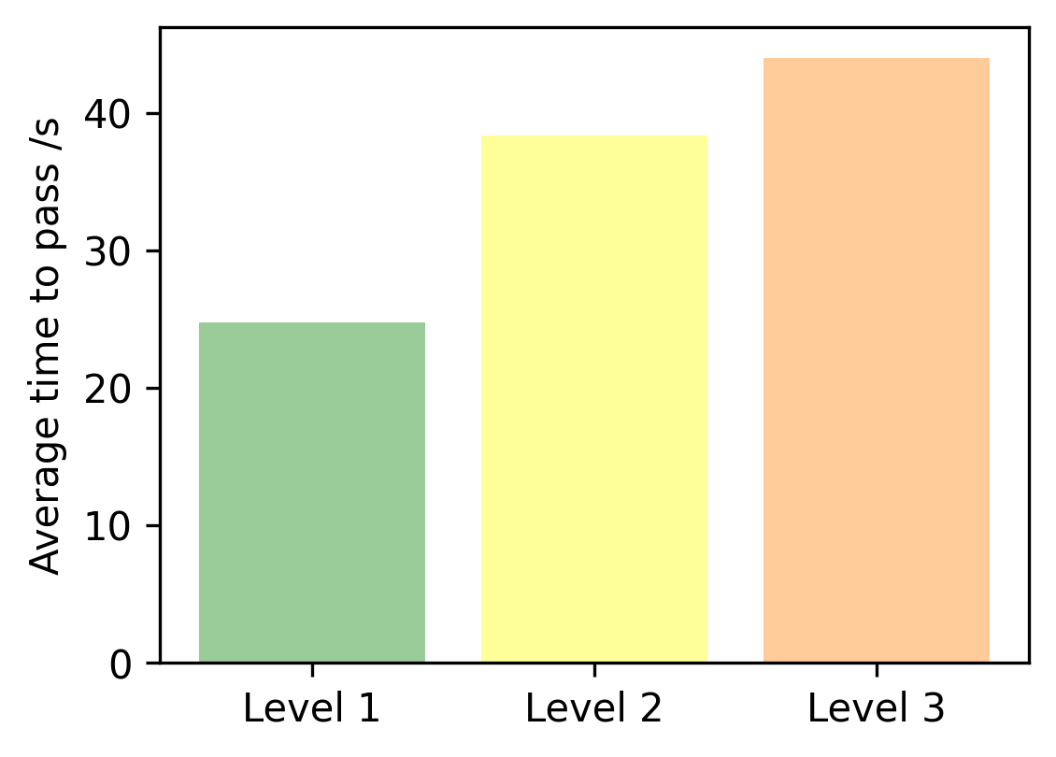

***How many players can reach each level?***

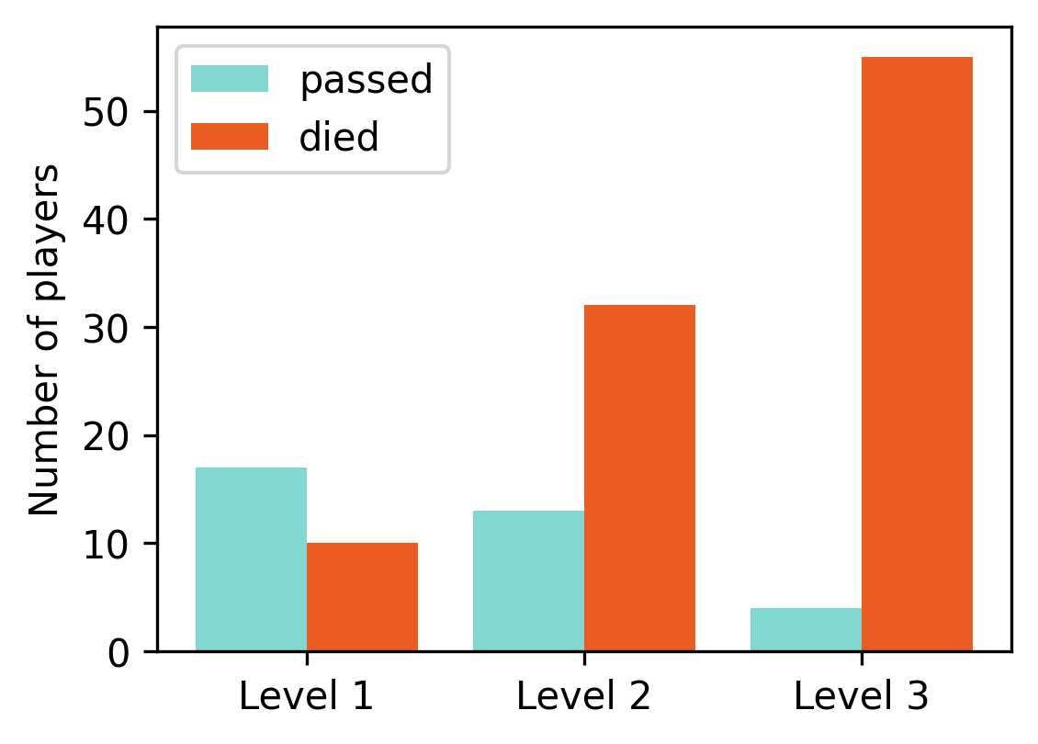

The reason to collect those two data is to measure the difficulties of each level. We can adjust the difficulty level based on the data. Data 1 tells us the time to pass each level, if one level needs a relatively short time, we might need to increase the difficulty of that level. Data 2 tells us the status of pass/death of each level. One level with more death than pass tells us that level is too hard to pass and we need to reduce the difficulty to prevent players from giving up our game.

## Data 3 & 4:

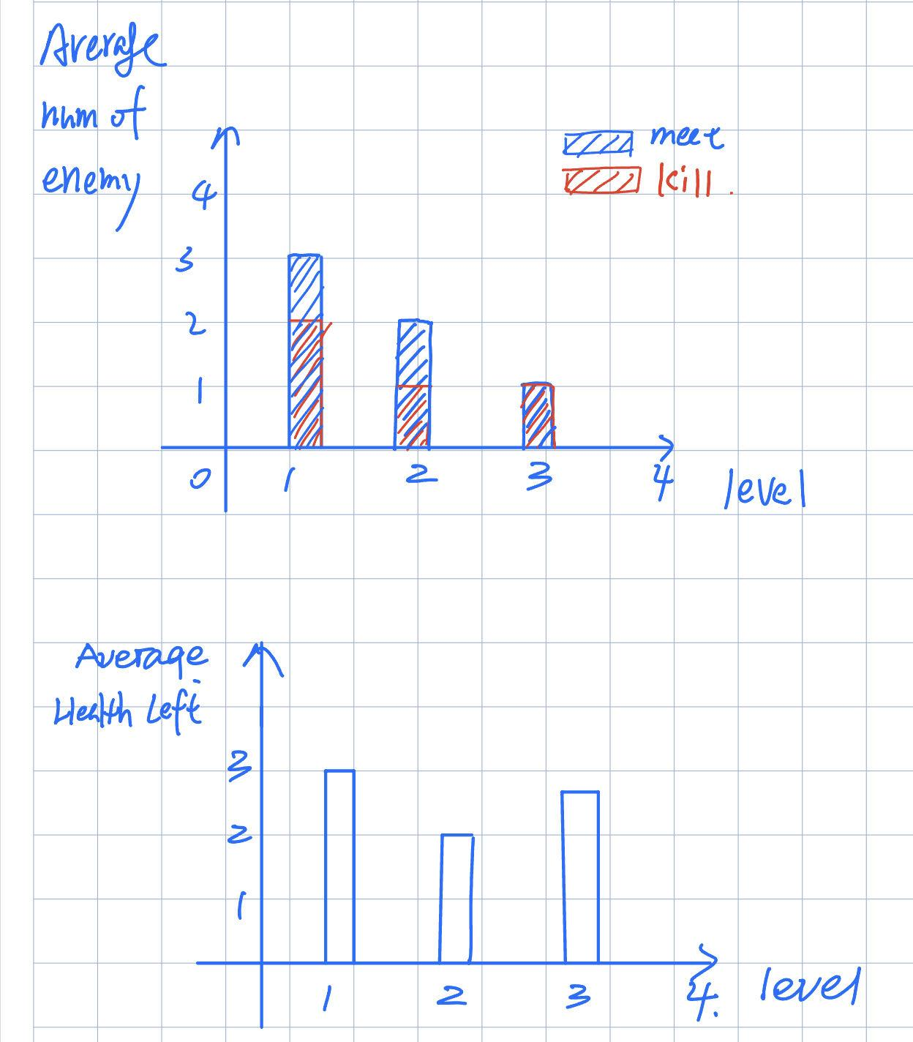

How many enemies a player kills vs total number of enemies they meet in each level.

What is the average health of player in each level?

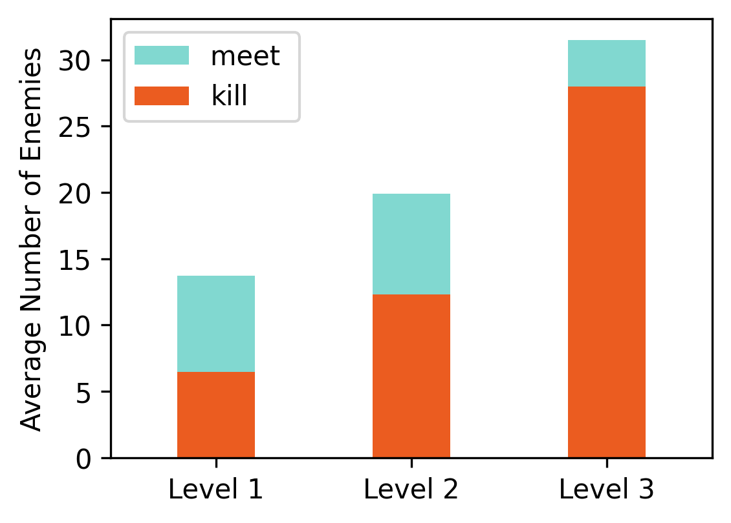

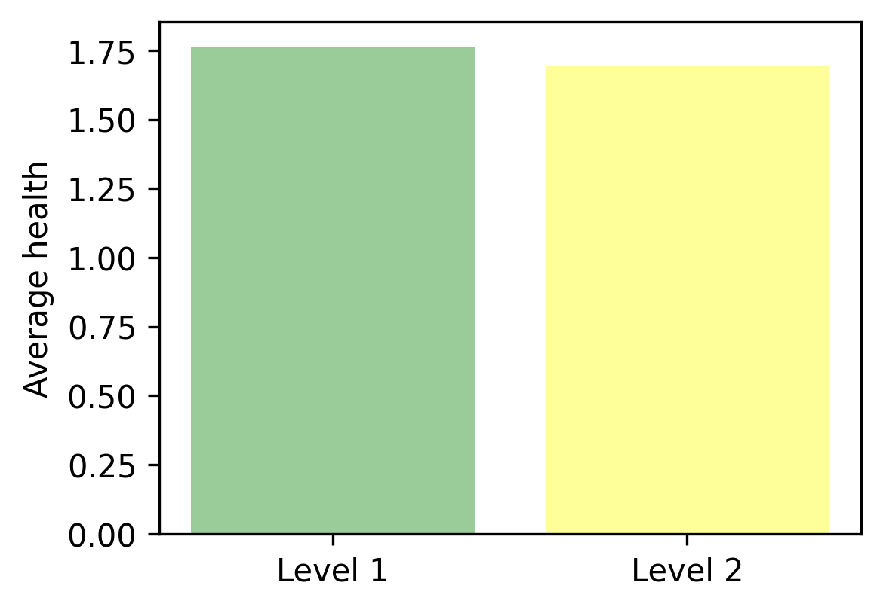

Data 3 tells the rate of enemies killed / total enemies. From this we can have an idea about how important it is for a player to kill enemies in order to pass a level. If players pass the level by killing only a few enemies, we need to change the goal of the level or change the point in that level.

Data 4 tells us the health a player has when they pass a level. It is important because we want to know if a play barely passed level or passed level without enough challenges.

## Data 5 & 6

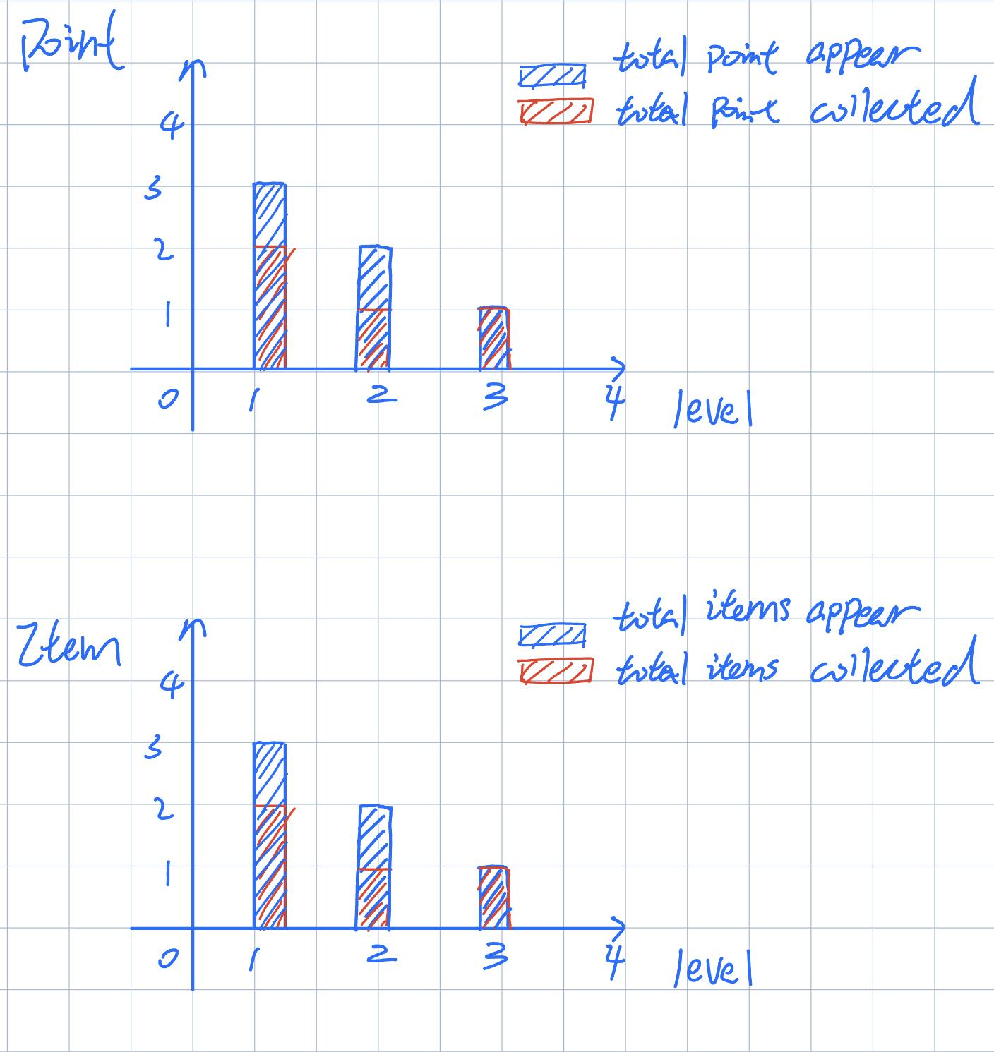

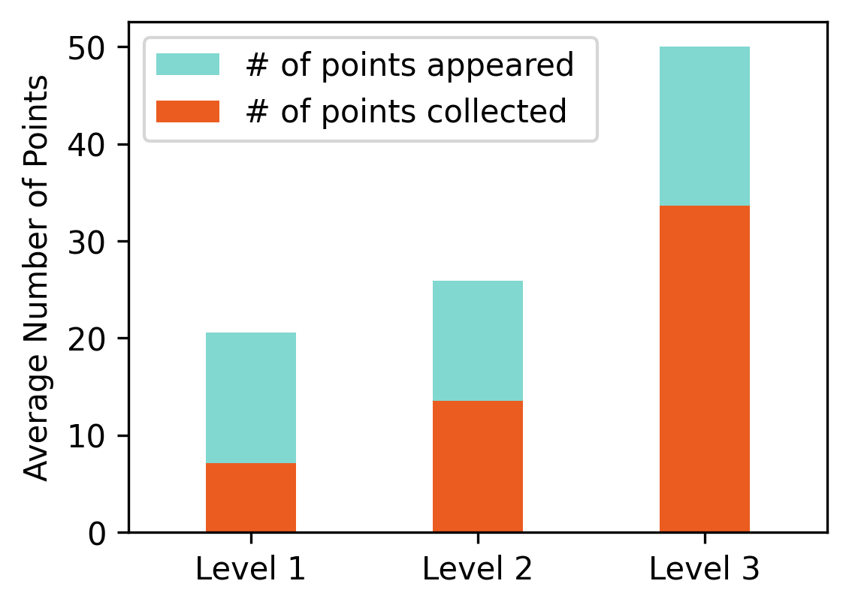

Date 5 shows the points collected on average for each level. We will adjust the number of points generated on each level, compared to the enemies they killed. The trade of between enemy players killed and the points players collected will decide the objective of each level and influence the player experience.

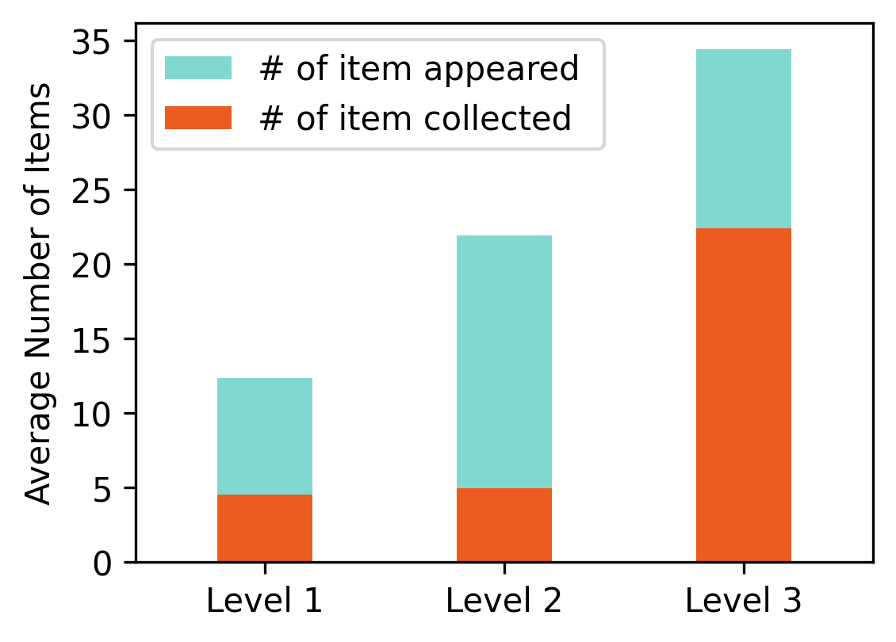

Date 6 shows the number of items collected on each level. We will check the average number of items collected on each level. If the rate of collection is too low. It might indicate that the items are not very attractive or the level is too hard for players to collect the items.

# Game Design Weekly Feedback

## Weekly Goal:

### Goal for 09/22

1. Player:
   1. Effect design
   2. Player health
2. Small circle
   1. Change size with score
3. Enemy:
   1. State showing
   2. Collision effect
   3. React with player
   4. Design enemy number
4. Start menu(Xiujing Huang)
5. BGM and sound effect (Shibo Zhang)
6. Level design (tutorial)
7. Data analytics

Level1: tutorial (Fixed enemies, points, and circle)

Level2: move enemies and circle

Level3: add props

### Goal for 09/27

1. Complete level 3
2. Add props/items(Chuanshi Zhu)
3. Enemy moves toward the player (Yang Zhang)
4. Add point to Player(Minzhi Zhan)
5. Limited green points and enemies(Tianding Zhang)
6. Adjust music effects (Shibo Zhang)
7. Add data analytics(Ruize Zhang; Mingdong Lyu)
8. Add level information (Yintang Yang)
9. Modify tutorial information and add some rules on level 1(Xiujing Huang)
10. Improve green circle / Add number on green circle (Mingdong Lyu)
11. Change level background (Zifeng Lin)
12. Change enemy score(Minzhi Zhan)
13. Modify GDD(Mingdong Lyu)
14. Fix Bug (Yintang Yang - Fixed game not end bug)
15. Adjust shrinking circle
16. Seperate the collision cs file

### Goal for 10/04

1. Add effects to items
2. Add level; Everyone thinks about one level
3. Enemy chasing the player
4. Add protection time after collision
5. Add explanation to the graphics analysis
6. Add shops;(skin; weapon; shoes)
7. Add unlimited mode
8. Different UI for different enemy

Zoom for UI:

Saturday 1:30pm

Zoom for level:

Saturday 4:00pm

## Feedback And Improvement

**9/6 Prototype Feedback**

* Short descriptor for mechanics to explore, new things.
* New element, sound/dance/colors. Combine it with somethings that has nothing to do the [genre.us](http://genre.us)

**Update:**

* Designed new game prototype
* Delete the all well-known elements
* Change the game mechanics and genres
* Create the game sprites by hand drawing

**9/13 2nd Prototype Feedback**

For other teams:

* Goal needs to be clear, the player needs to know what to do. (Exit sign/door instead of blue square)
* Break up teams and individually think of little ideas/mechanics to add to the game. Vote for best ideas.
* Communication to the player is important through guidance instead of text instructions.

For our team:

* Hard time understanding role, missing validation of doing the right thing.
* No obvious reward/danger.

Update:

* Add progress bar to remind player’s status of each level
* Add more information on screen to help players understand the game concept.
* Add sound effects to demonstrate the reward/danger
* Change the enemy color based on the division
* Use different colors to separate enemies with different scores.
* Add game menu and User interface

**9/20 Feedback**

* Assumes boxes are enemies
* Not sure how to divide enemies
* Not sure what ‘divide’ means, thought cut in half
* Understands not to touch the outer ring
* Still doesn’t understand how the division works
* Does not understand what progress bar refers to
* Likes the concept, thought the limit was short but didn’t realize

**Update**

* Change the enemies’s sizes to separate different kinds of enemies rather than use different colors.
* Add one tutorial level to help new players understand our game
* Update the enemies colors when they can be eliminated
* Change all friendly objects including points and enemies to be killed to green.
* Add health system to illustrate the penalty more stragefowardly.
* Add interaction for players collecting points as well as getting damages.

**9/26 Feedback**

Presentation tips

* Speak from the audience point of view
* Elevator pitch: give a clear description that explains the game thoroughly
* Sell the point of the game
  + Don’t assume knowledge from user
  + Say things like: It’s a math game visualized, the mechanics include…

**Improve GDD**

1. Lack of mechanic detail
2. Update Google sheet
3. Github main branch update
4. Take notes and put it on GDD
5. Add change based on feedback

**Update**

* Complete Level3
* Add props to have some special effects
* Delete background music
* Adjust the number of enemies
* Adjust the shrink circle speed
* Limit the total number of enemies
* Visualize the total score on player

**Oct 4 Student Observation**

* Student 1 understands the game through the tutorial level, but doesn’t realize he needed to click on ‘skip’ in order to continue
* Notices the same movement design from the enemies
* Does not notice the circle shrinking mechanism introduced in level 2
* Unsure about the effect of the powerup
* A bit unclear about the total score

**Oct 4 TA Feedback**

* Not enough progress shown. Little changes compared to two weeks ago.
* Team should be actively exploring mechanics, responding to playtesting and feedback.
* Each team member should be spending around 8 hours per week on the project.
* For analytics: provide thorough explanations not just to say what it is, but about what it can help us say about our game.
* Remember to add games we played during the first week.

**Update**

* Add level; Everyone thinks about one level
* Enemy chasing the player
* Add protection time after collision
* Add explanation to the graphics analysis
* Add shops;(skin; weapon; shoes)
* Add unlimited mode
* Different UI for different enemy